### Slice Form Bride and Groom Cake Topper or Table Decoration

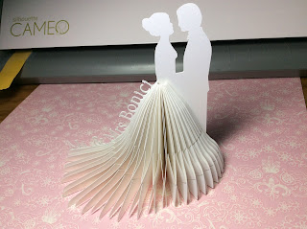

Plain paper cake toppers are boring. I have taken the paper cake topper to the next level with my slice forms. I think it is amazing to see the angles that are formed with the slices and this is the reason why I love paper so much.  
  
I used Neenah Metallic 8 1/2 x 11 paper for this project. I think you can get it at Walmart or Office Depot.  
  
  
Cut out all of the slices once for half of a skirt or twice for a full skirt. Please note, I recommend cutting the front slices first and putting it together before proceeding to cut out the back of the skirt. The slices are graduated to form the train. There are two special slices which form the starting and ending points of the slice form.

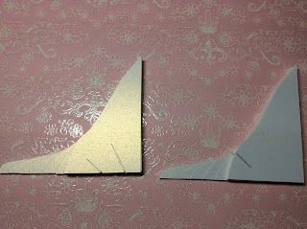

Slices are sorted according to their slits and graduated from largest to smallest as show above to create two piles.

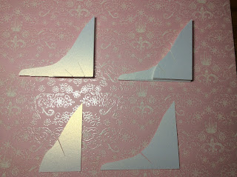

Two special slices are at the bottom of this picture.

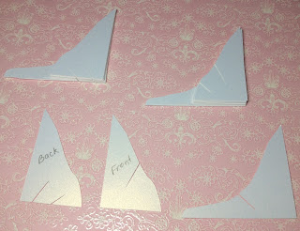

Take one of the smallest slices with the two slits on the bottom and write the word "back" on its side as shown. The positioning of the words dictates if the slices will be the front or the back of the skirt.

Write "front" on the small special slice with one slit on the side as shown in the photo above.

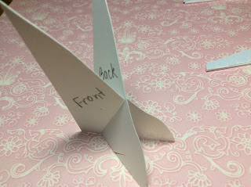

If you want to make the front of the skirt, make sure the word "front" is in front after sliding the two pieces together.

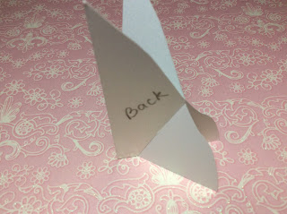

If you want to make the back of the skirt, make sure the word "back" is in front after sliding the two pieces together.

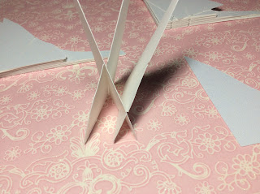

Notice that you made an 'X' when you slide the pieces together. You will be making an 'X' each time you slide a piece together. The first 'X' was a top 'X' and the next slice created a bottom 'X'.

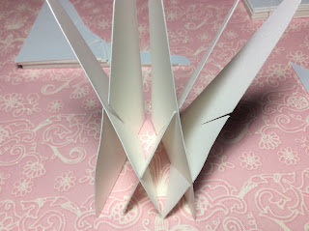

You will be alternating slices from each pile to create this top and bottom 'X'.

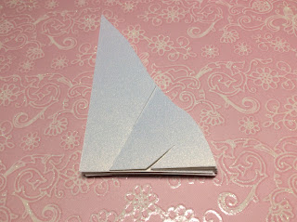

You can lay the piece flat on a work surface if you are having problems.

Make sure the bottom 'X' is the same size slice when doing the train portion. If the pieces get out of order, the skirt train will be uneven. (This has happened to me so don't make my mistake.)

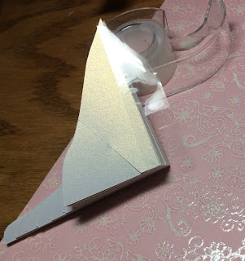

Once completed with the slices, cut a piece of tape the height of the skirt. Apply the tape to the side edge of the skirt to bind the slices together like a book.

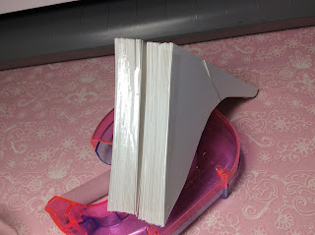

Repeat for the back side of the skirt. Notice the glossy edge...that is where the tape is.

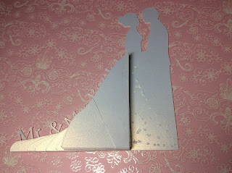

Glue the front skirt to the figure.

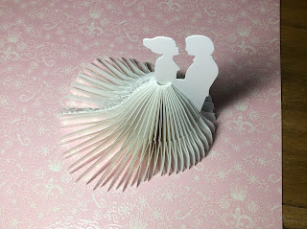

Glue the back of the skirt to the figure.

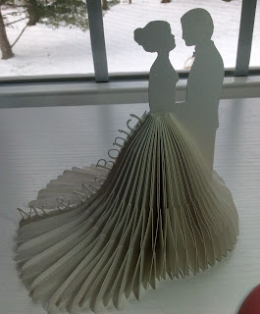

I added a name to the edge of the figure. You have the option to add a name if want in Silhouette. Using the figure with no wording. Type the name in Silhouette Studio and move the words to the figure by dragging the circle by the words to the figure. Highlight the words and the figure together. Go to Weld and weld the letters to the figure.

I hope you enjoy making this decoration as much as I did.